IYogaFest 2025 - Talk Notes:
The Foot – Structure, Function, and Yoga Integration

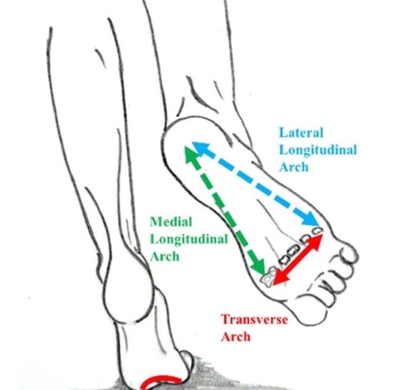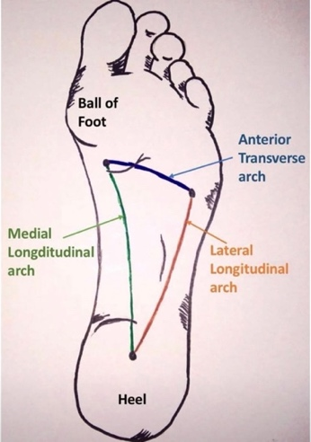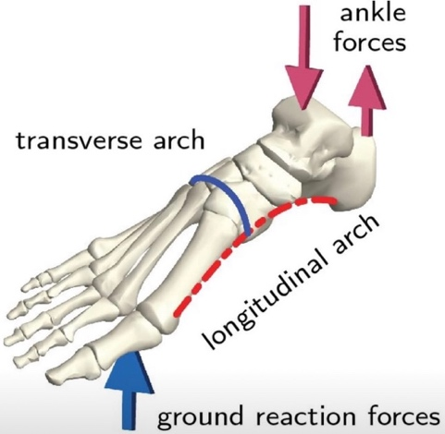

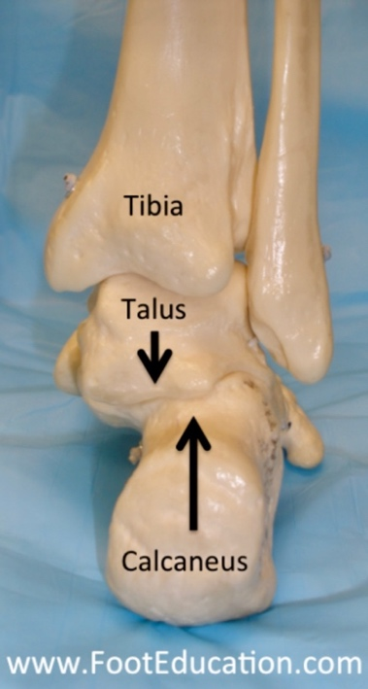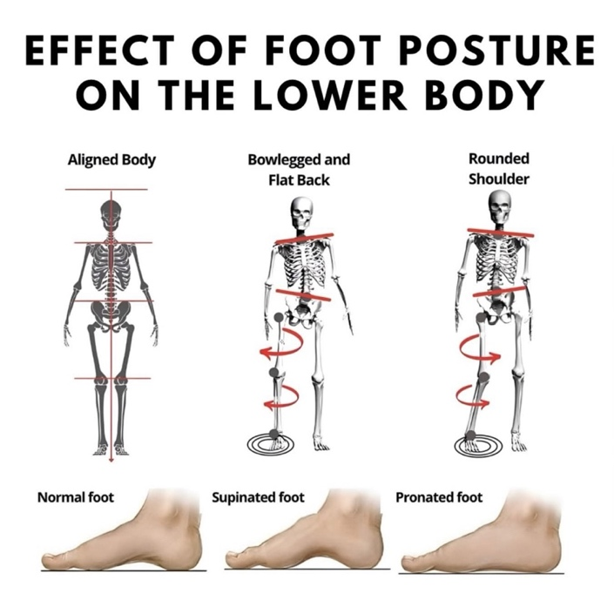

1. Engineering Each foot contains 26 bones, 33 joints, and over 100 muscles, tendons, and ligaments, working together to provide balance, shock absorption, and movement. That’s almost a quarter of all the bones in your body packed into your feet.
2. Load-bearing Feet bear up to three to four times your body weight when running or jumping. Over an average lifetime, a person may walk the equivalent of four times around the Earth on their feet.
3. Rich with nerves The soles are among the most sensitive parts of the body, packed with nerve endings. This sensitivity helps with balance and proprioception (your body’s awareness of where it is in space), and also explains why most people are ticklish on their feet.

Explore Your Bony Landmarks
- Ankle bones – tibia and fibula
- Toe mounds and length of metatarsals
- Big toe joint – sesamoid bones
Major Muscle Groups of the Lower Leg and Foot – Try These Movements
1. Front (Anterior compartment) – lifting the foot
- Tibialis anterior – lifts (dorsiflexes) and inverts the foot
- Extensor hallucis longus – lifts the big toe
- Extensor digitorum longus – lifts the other toes
- Peroneus tertius – helps lift and evert the foot Important for walking, stepping, and preventing “foot drop”
2. Outer side (Lateral compartment) – stabilising the arch
- Peroneus longus and brevis (fibularis muscles) – evert the foot (roll it outward) and support the arch Help with balance, especially on uneven ground or in single-leg poses
3. Back (Posterior compartment) – pushing off and pointing the toes
Superficial group:
- Gastrocnemius (big calf muscle, two heads) – jumping, running, rising onto toes
- Soleus – deeper, endurance muscle for standing and walking Together they form the Achilles tendon, attaching to the heel bone (calcaneus)
Deep group:
- Tibialis posterior – supports the arch, inverts the foot
- Flexor hallucis longus – flexes the big toe (very strong in push-off)
- Flexor digitorum longus – flexes the other toes
- Popliteus (behind the knee) – unlocks the knee for walking Essential for balance, propulsion, and the integrity of the foot’s arches
4. Intrinsic Muscles of the Foot (inside the foot itself)
- Tiny muscles between the bones: lumbricals, interossei, flexor digitorum brevis, abductor hallucis, abductor digiti minimi, etc. They fine-tune movement, help spread the toes, and keep the arches lifted Often weak from shoe-wearing but strengthened beautifully through yoga standing poses
Key Tendons
- Achilles tendon – connects calf muscles to heel; strongest tendon in the body
- Plantar fascia – thick band of connective tissue from heel to toes, supporting the arch
- Extensor tendons – run across the top of the foot, lifting the toes
- Peroneal tendons – run behind the ankle bone on the outside, stabilising the foot
- Posterior tibial tendon – runs behind the inner ankle, supports the arch
In Yoga Terms
- Front muscles help flex the foot in Utkatasana or maintain balance in Vrksasana
- The calf–Achilles complex works in Adho Mukha Svanasana and Urdhva Prasarita Eka Padasana
- Intrinsic foot muscles engage in Tadasana, subtly lifting arches and drawing energy upward
The Arches – Explore on the Drawings and Your Own Feet
When we begin, we often:
- Spread the toes
- Lengthen the foot forward from the heel
- Extend backwards from the toes
These actions prepare the whole leg and hip for movement.
Lying Down – Supta Padangusthasana 1
- Use a belt to the toe mound
- Watch how delicately the feet respond and how the arches become highlighted
- Roll the skin of the top of the foot from the little toe towards the big toe
- Feel how this inspires the whole leg
Swap sides and explore the difference:
- Position the belt over the tip of the heel
- Why does the front of the foot highlight soft tissue, and the heel highlight bone?
It’s about the different forces in these areas and how the nerves signal the muscles to respond.
The Nerves – How Motor and Sensory Nerves Work Together
Motor nerves (movement)
- Carry signals from the brain and spinal cord to the muscles in the feet
- Activate both the small intrinsic foot muscles and the larger muscles that move the foot
- Control lifting the arch, spreading the toes, pointing or flexing the foot, and adjusting balance
Sensory nerves (feeling)
- Carry feedback from the foot back to the brain
- Detect touch, pressure, pain, temperature, vibration, and proprioception
- Help you feel whether you’re standing evenly, if the floor is rough or smooth, or if you’re overstretching
Developing Proprioception
As your practice develops, you stop needing to look at your feet to check alignment. Think of learning to drive a car — at first you look down to find the pedals, then eventually, you know instinctively where they are.
The same thing happens in standing poses — eventually, the feet give all the feedback you need.
Even in poses like Ustrasana or Bharadvajasana, the position of the feet continues to affect the entire body.
Working Together
When you jump or step into Tadasana:
- Sensory nerves tell your brain how your weight is distributed
- The brain sends signals back through motor nerves to adjust the muscles
- This creates a constant feedback loop: feel → adjust → feel again This is why yoga is such a powerful training ground for awareness and stability
The Heels
- Look at the shape and position of the heel bone
- Most people naturally roll onto the outer edge of the foot
- So we instruct: roll the big toe down and lengthen the inner leg
Over time we refine:
- Rolling the big toe down too much can create flat feet
- Balance this by pressing through the outer heel
- This in turn signals the hip to respond and refine alignment
Back Foot in Forward and Lateral-Facing Poses
Try this:
- Stand with feet wide inside a looped belt
- Put the belt around the outer feet and extend
- What do you feel? Knees knocking? Front thighs dropping?
Now move the belt down to the outer heel, below the ankle bone:
- This creates greater stability — used in Prasarita Padottanasana with a double belt
Turn your feet for Trikonasana or Virabhadrasana II – start from feet parallel.
- Try turning just enough to put the first toe where the big toe sits.
- What angle is that? How does it feel?
Now try Parsvottanasana or Virabhadrasana I – start from feet parallel.
- Try turning just enough to put the little toe where the big toe sits.
- What angle is that now? What happens to the outer heel and the front thigh?
If pressure moves to the little toe edge, the front thigh may drop. At around 60–70 degrees, the inner thigh can help ground the outer heel properly. Too far, and pressure shifts toward the big toe side.
Spiral Action
All limbs require a spiral action in order to straighten — that’s how muscles, tendons, and ligaments are organised.
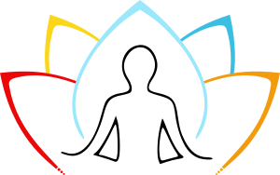
For every push or pull in one direction, we need an equal and opposite in the other. Like wringing out a cloth — a useful image for how the posture of the feet influences the whole body.

www.hannahlovegrove.com
hannah@hannahlovegrove.co.uk

